DW: Website 2 - Brainstorming Rishe
AAD 85 - TTH

JEROME CUYOS

Website name: jeromesDesign
Curriculum Vitae

Catchphrase or tagline: Personal Portfolio

Summary of the purpose of the website:

To provide a summary of my experience and skills.

Target Audience Information:

- Age: 28 years old and above
- Gender identification: General
- Hobbies or interests or lifestyle: Employer’s, Business Owners, Proprietors and more
- Economic level: Business and Personal
- Other key identifiers:

Colors Palettes:

Palette 1:

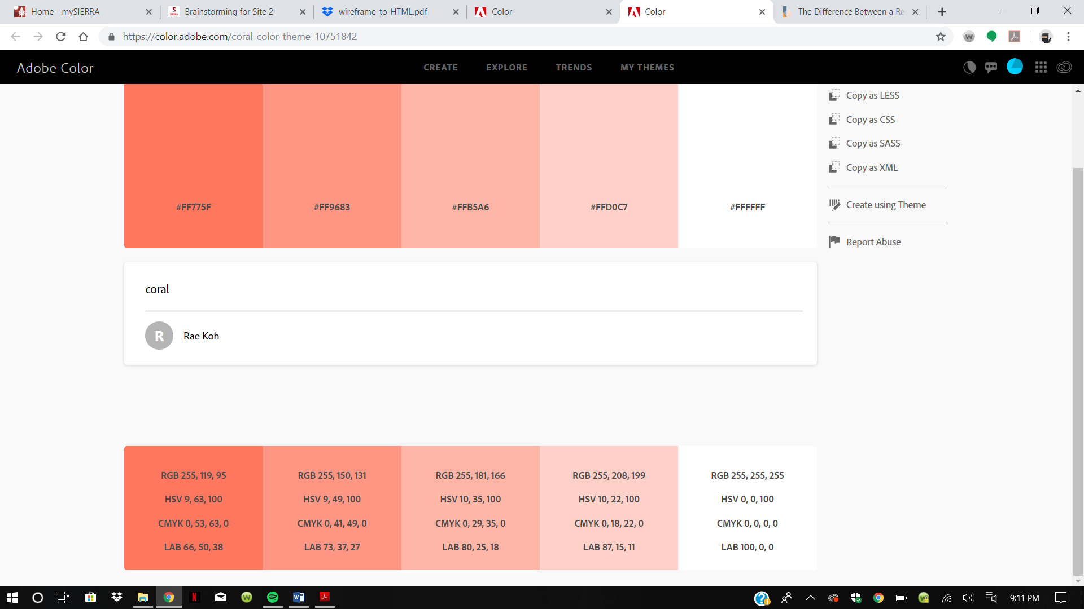

This color palette signifies the coral colors views as a precious subject of life.

Palette 2:

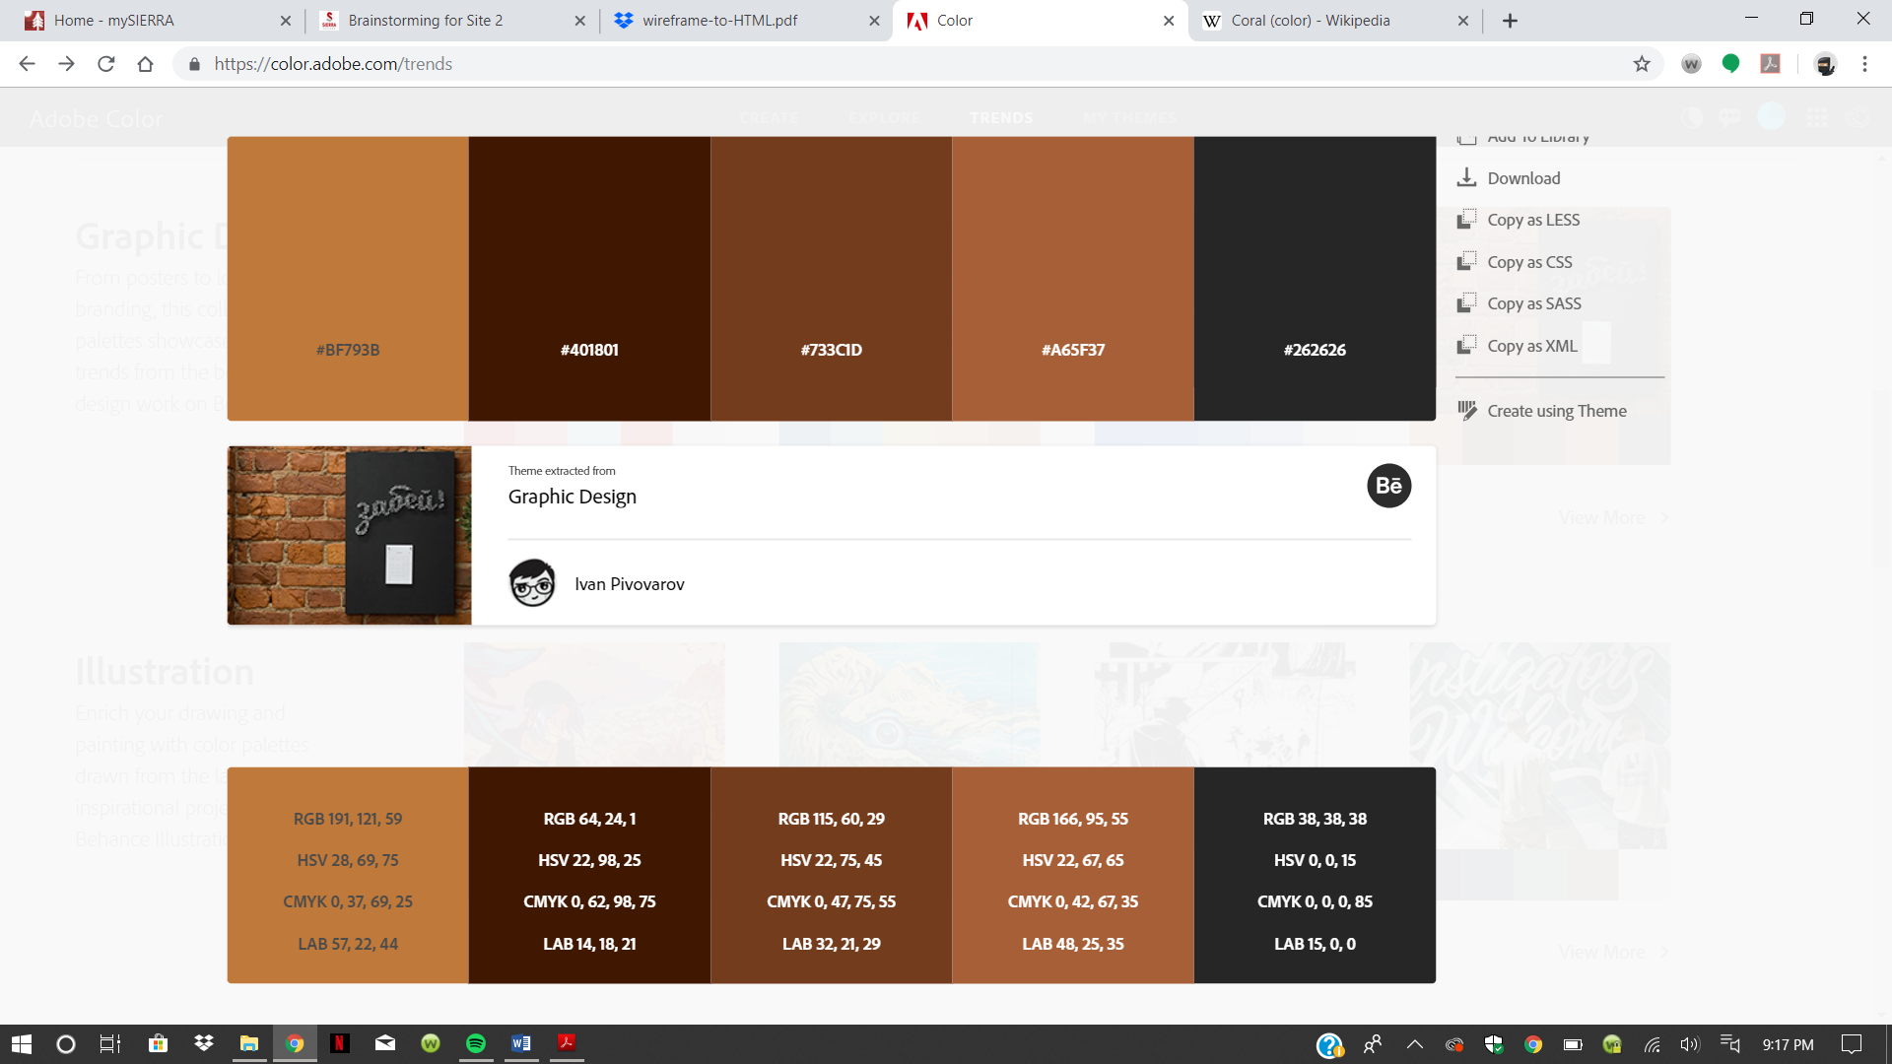

This color palette signifies the life in a creative design wold.

Inspirational Websites:

- Site 1: hhttps://www.mangomolo.com/#

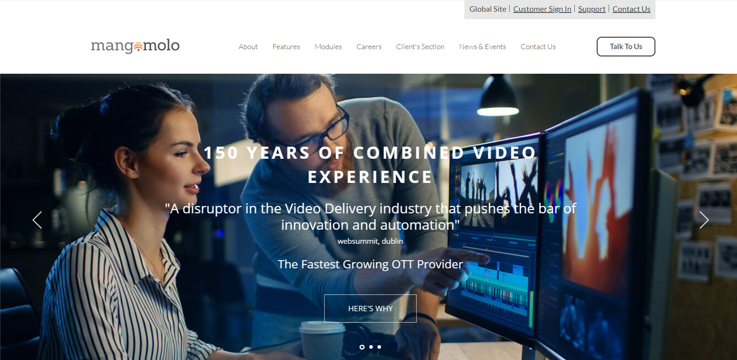

I specifically want to model from this site the layout.

- Site 2: https://www.lonelyplanet.com/usa/california/southern-california

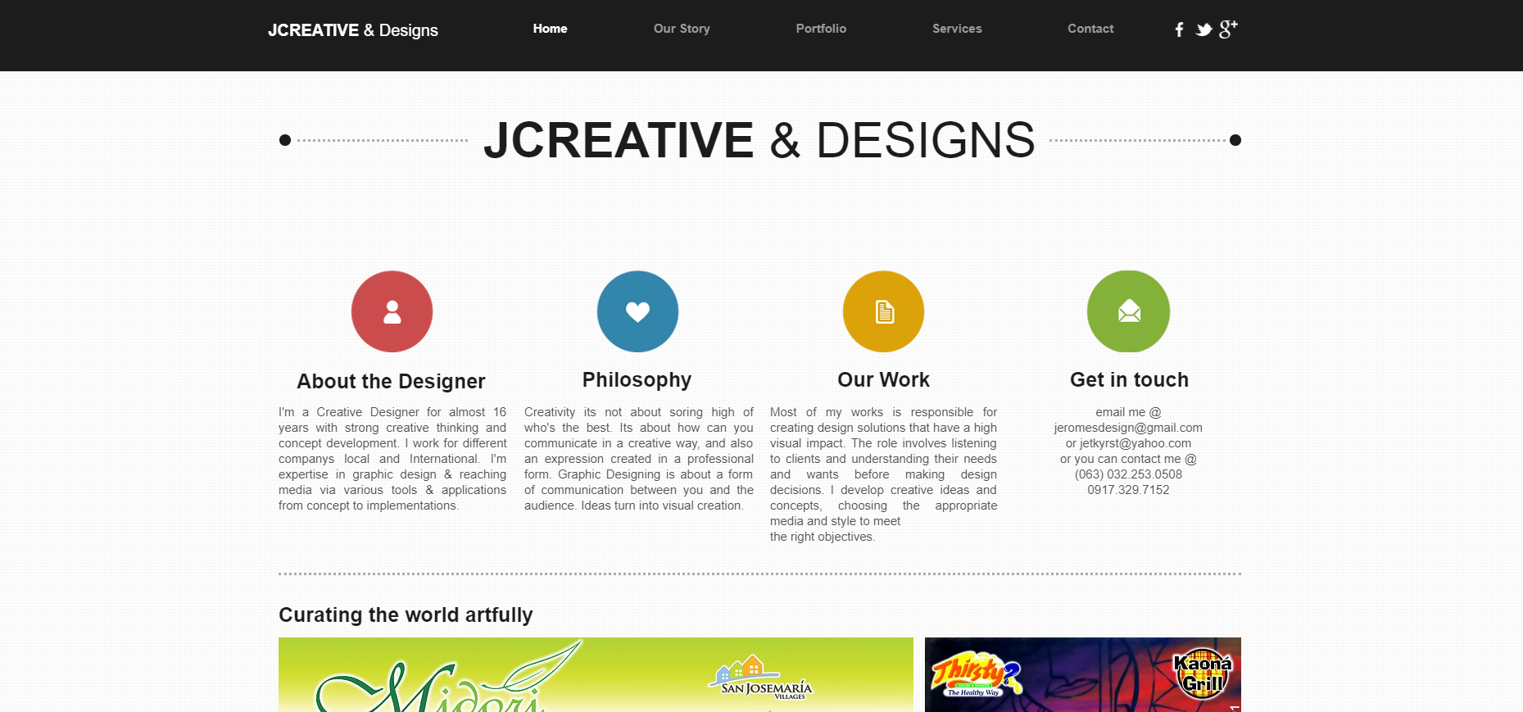

I specifically want to model from this site because this is my personal site that I created through wix.com website builder. I just want to enhance this more with my personal touch.

